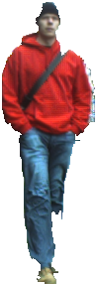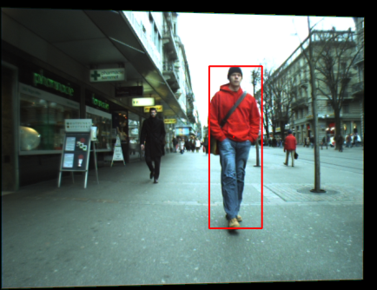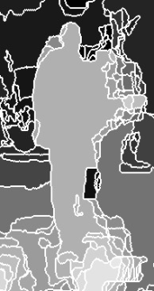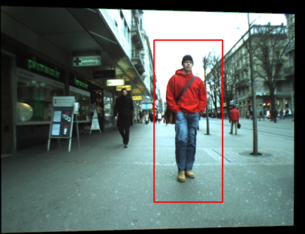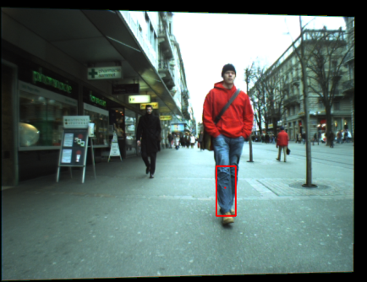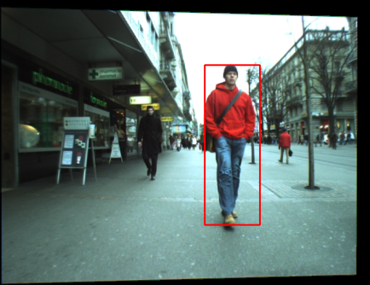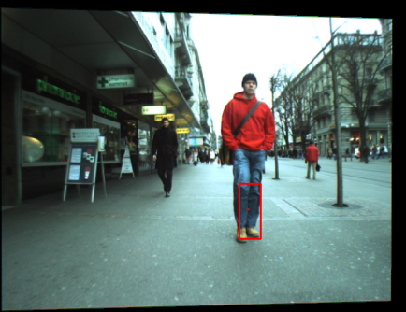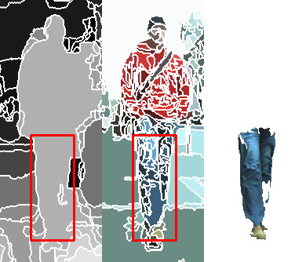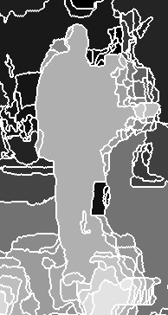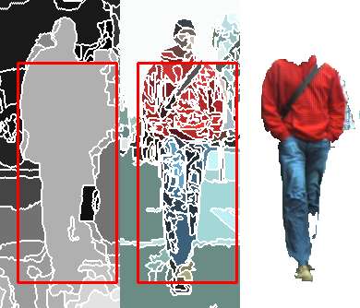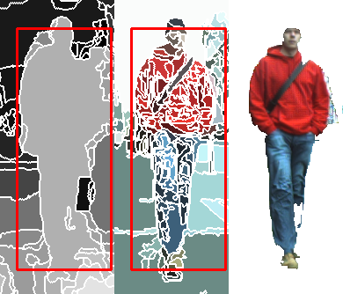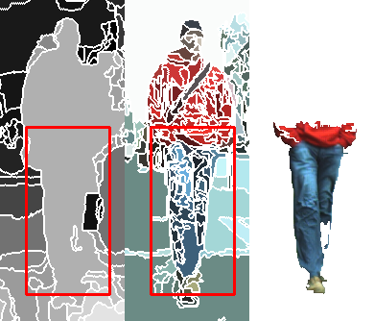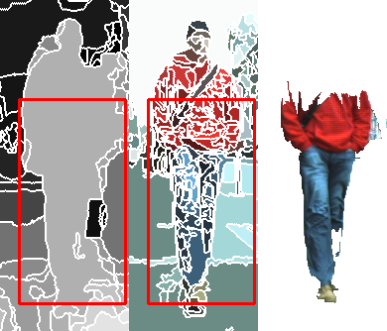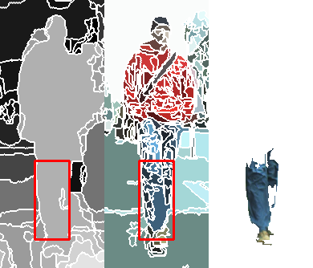

Immediate Previous Frame

Current Frame After Depth Crawling

Current Frame Before Depth Crawling

Shrinking in Current Frame

Refined Figure

Figure 2. Outliers exclusion using depth shrinking towards dominant depth group

Figure 1. Figure recovery using depth crawling along dominant depth group

**Dominant Depth Group**

# D:\DATASET1\supply\crawling\dominant.bmp

From Fig. 1 and 2, we show the effectiveness of our figure-ground segmentation engine via testing on two extreme cases. In Fig. 1, we manually adjust the scale of the tracker to cover only small part of the tracking figure in the immediate previous frame (the pedestrian dressed in red). In the current frame, our tracker first finds the dominant depth group and in turn conducts a loopy adjustment process to crawl along the dominant depth until all super-pixels with high confidence to the object are encompassed by the bounding box. Through this case, we can clearly see our depth-driven tracker’s strong capability of self-recovery on object scales in spatial-temporal domain which ensures its robust tracking in dynamic scenes. In Fig. 2, when the previous bounding box includes a large amount of outliers (but the object still holds the dominant depth group), the depth-driven shrinking process will eliminate those outliers automatically which greatly reduces the possibility of drifting. In addition, this appealing property of scale self-recovery shown in Fig. 1 and 2 also ensures robust tracking when the tracker suffers from bad model initialization (from manual or detector), or occasionally heavy outlier corruption.

Tracking Result

Immediate Previous Frame

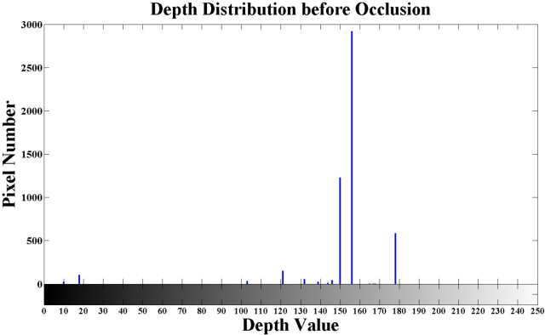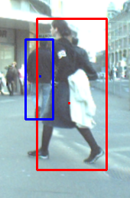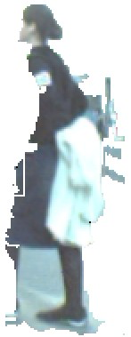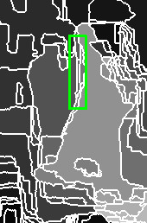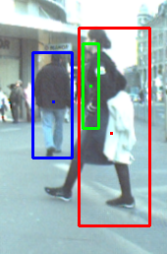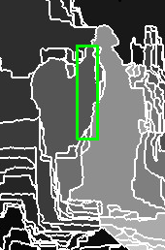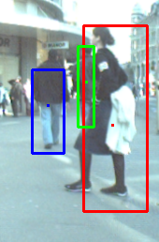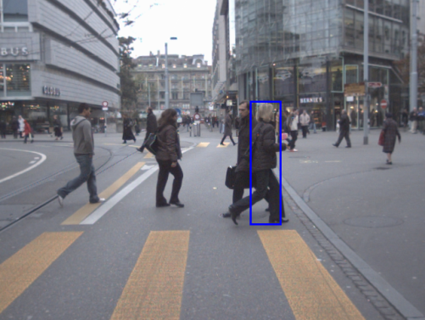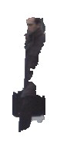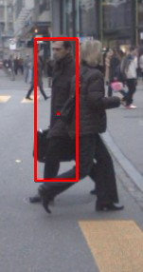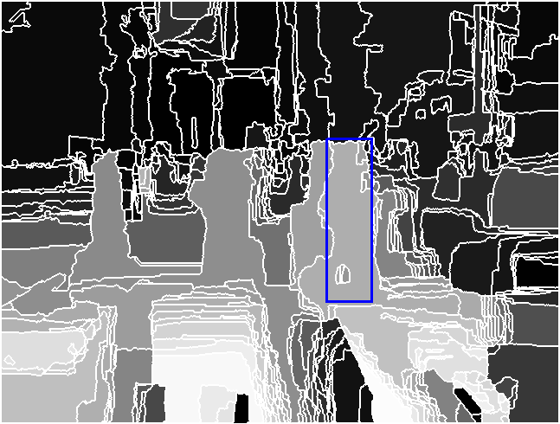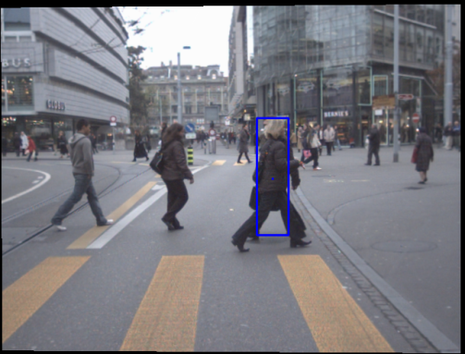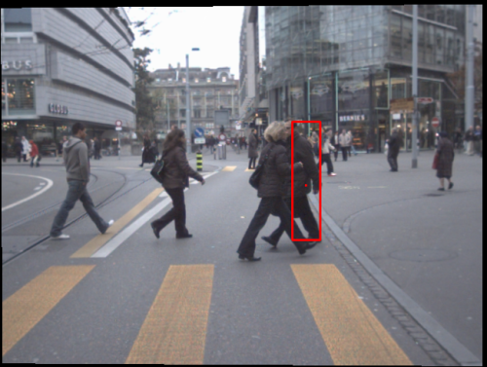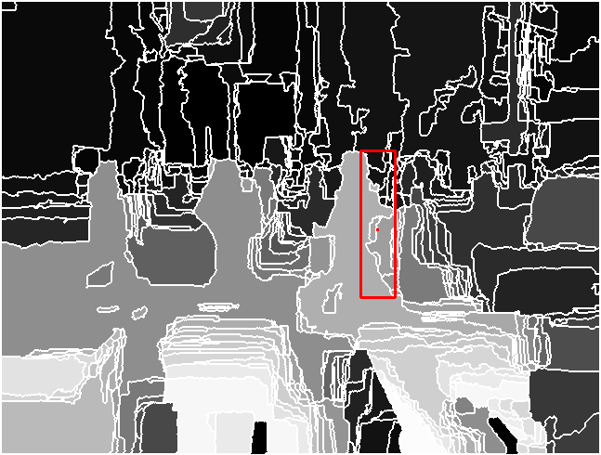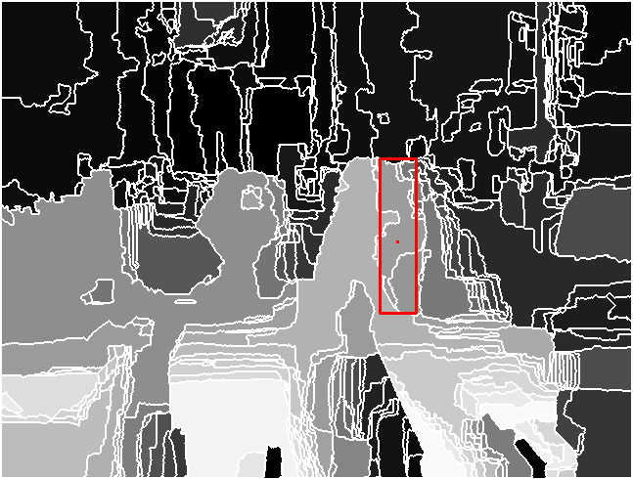

In Fig. 3, we show the process of detecting occlusion using sharp depth change within the original object region. When occlusion happens, the tracker immediately grabs the **OB** with occluding depth value (closer to the camera) and tracks it until the original object reappears, while repetitively “planting” depth seeds (red dots) near the **OB**. If the depth seeds can be extended to be part of the object (purple dots in figure 3), the tracker can regain the object after complete occlusion. In Fig. 4, the object (green) undergoes sharp appearance change and fast location movement showed by yellow symbols. The tracker will plant depth seeds around the previous location and find the **OB** and track it.

Note: each depth seed holds the same scale as the scale of tracking object before full occlusion.

Figure 4. The process of Occlusion Detection through sharp appearance change and fast location movement

**OB Tracking**

**Detected OB**

**Object (green) under Occlusion**

**Object (green) before Occlusion**

**Depth Seeds Planting**

Figure 3. The process of Occlusion Detection through sharp dominant depth shifting and object reacquisition

**Depth Distribution of Original Object Region in Current Frame**

**Depth Distribution of Original Object Region in Previous Prame**

**Tracking Result**

**Object**

**Reacquisition**

**Tracking Result**

**OB Detection**

**OB Tracking**

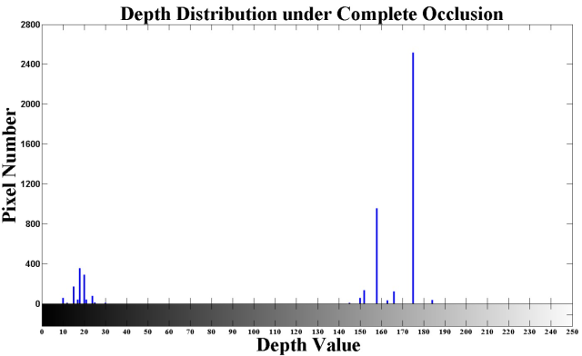

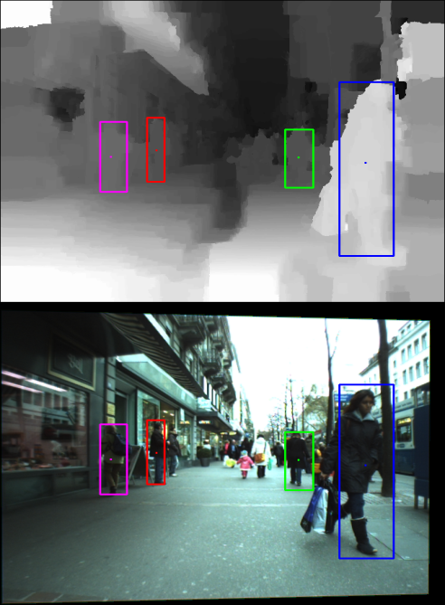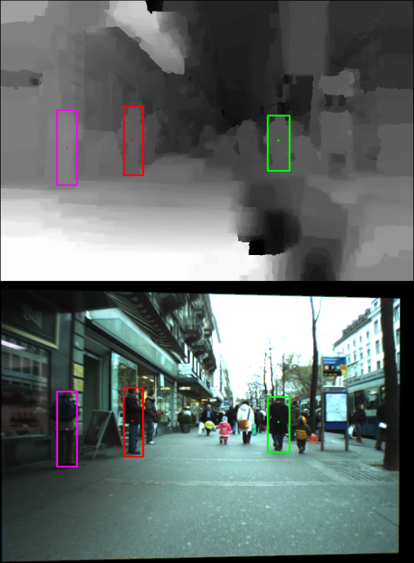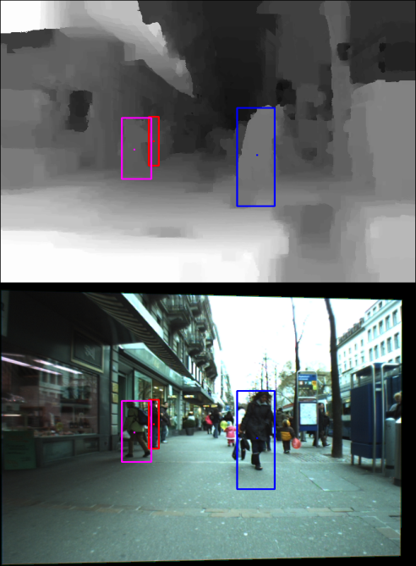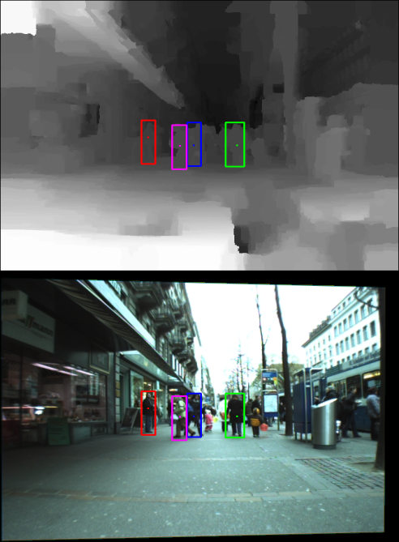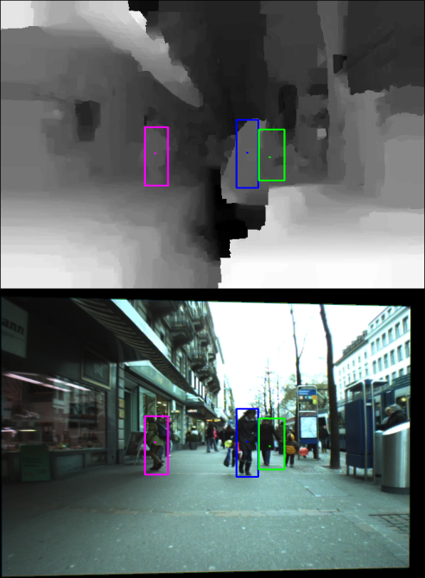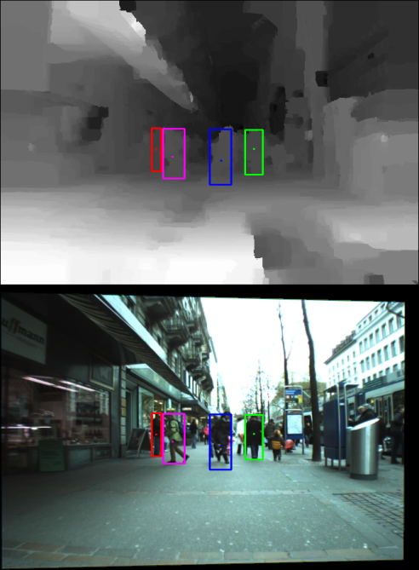

**461# 469# 476#**

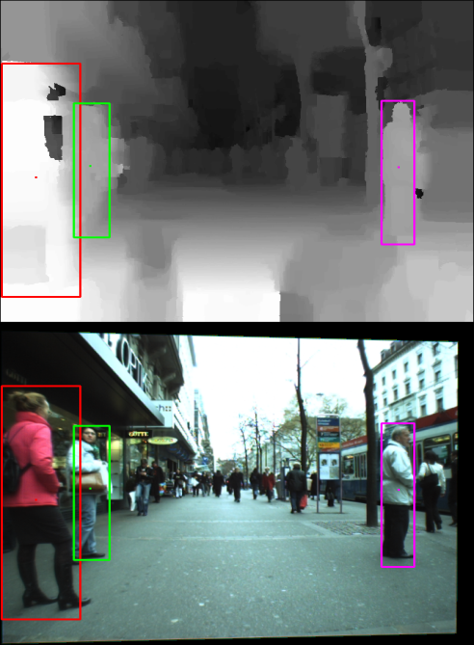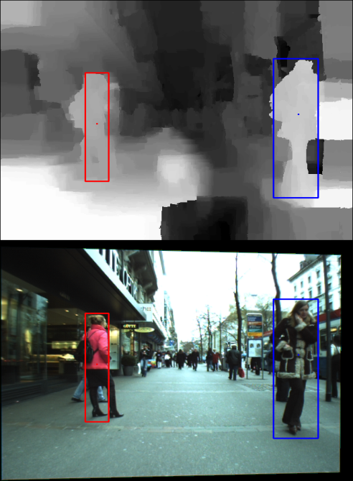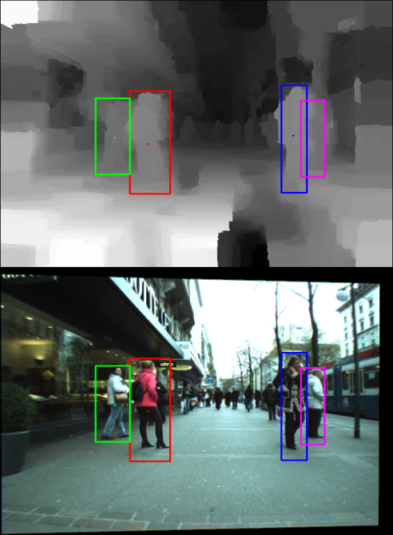

Figure 5. Tracking results on both depth map and color image of key frames in subsequence Bahnhof.a (460#~515#) and Bahnhof.b (621#~670#). At frames 476, 482 and 651, some targets are under complete occlusion and trackers regain them in following frames, shown at frames 482, 494 and 651. In addition, appearance of the object bounded by pink box in Bahnhof.a undergoes a rapid change due to sharp illumination alteration.

**641# 651# 665#**

**482# 494# 506#**

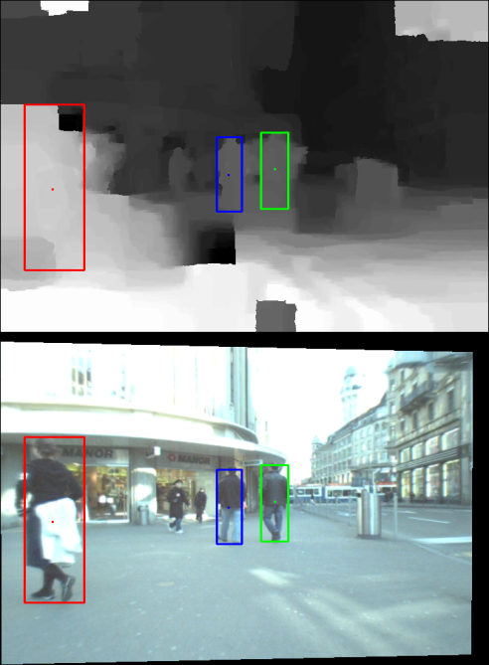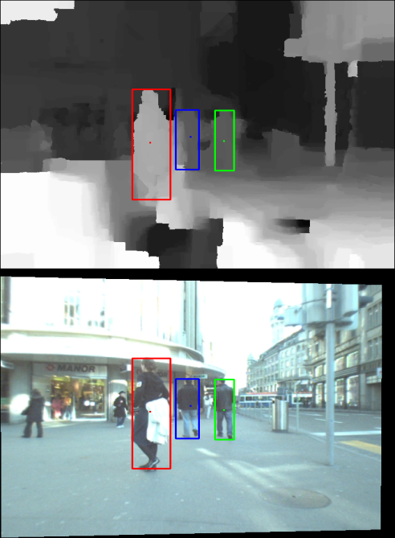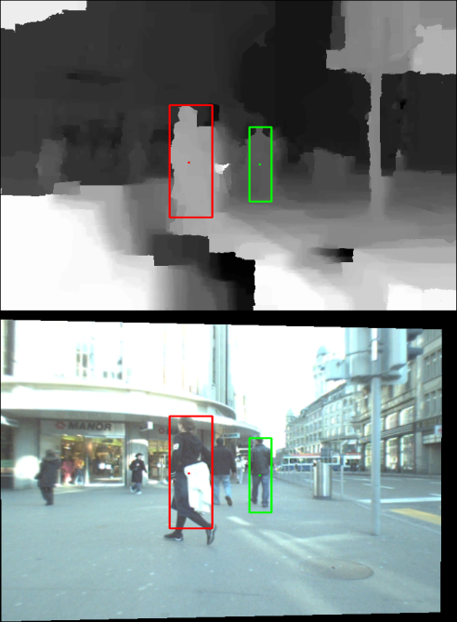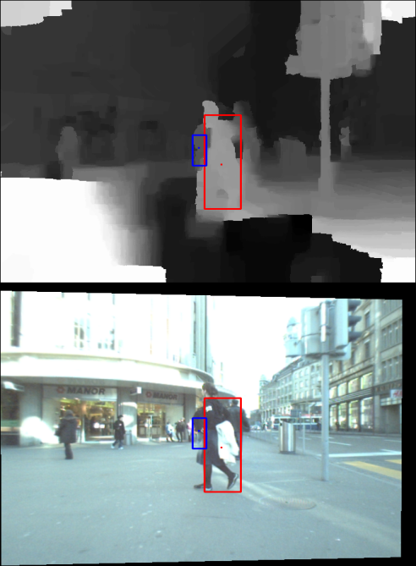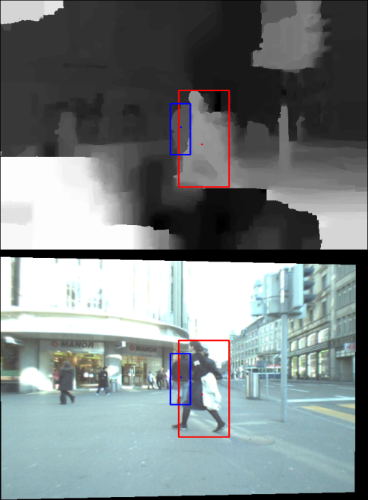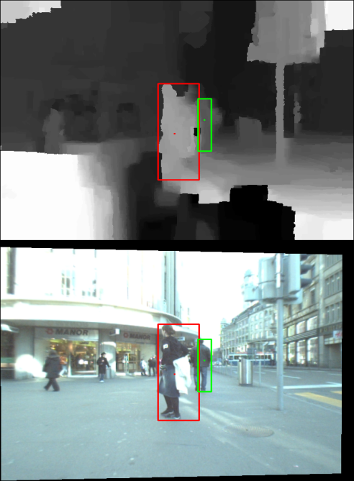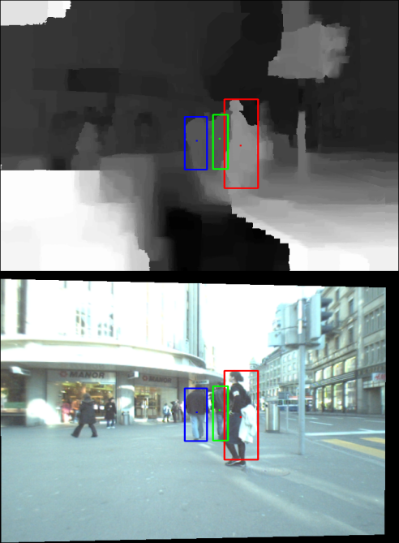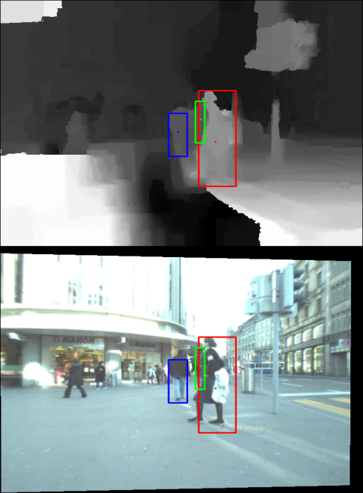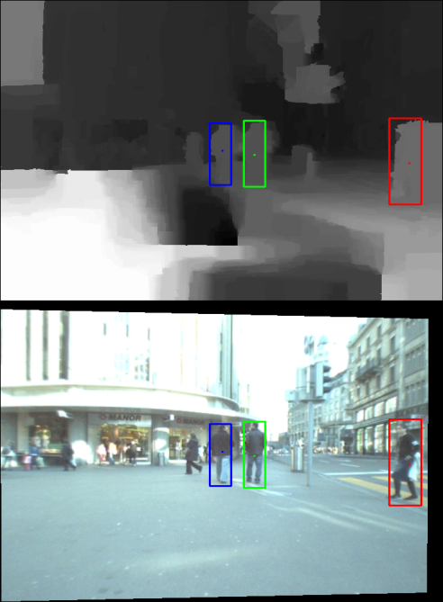

Figure 6. Tracking results of Jelmoli.b (581#~786#) subsequence. At frames 760 and 764, objects bounded by green and blue box are completely occluded by the object bounded by red box respectively after heavy interaction between frames 756 and 763. Although the tracker fails to reacquire objects in 762 (green one) and 769(blue one) due to inaccurate depth estimation caused by stereo occlusion around objects, they can still relocalize objects when the depth cue is reliable at frames 764 and 771.

**769# 771# 784#**

**760# 762# 764#**

**726# 756# 757#**

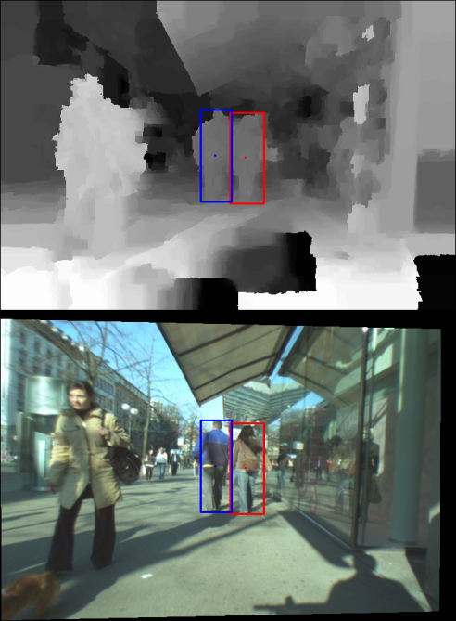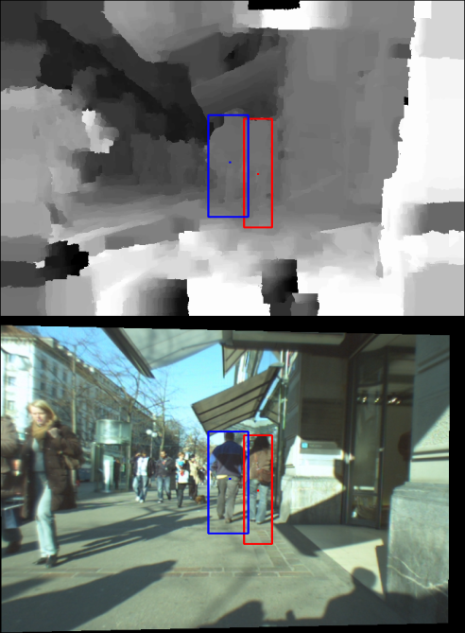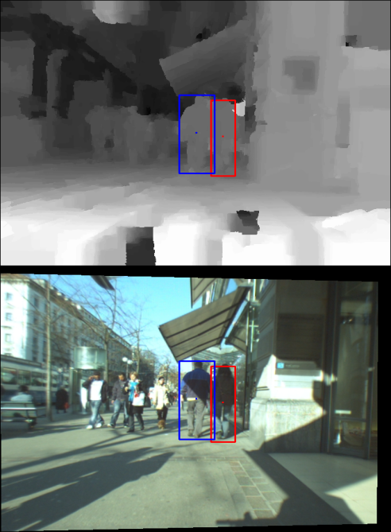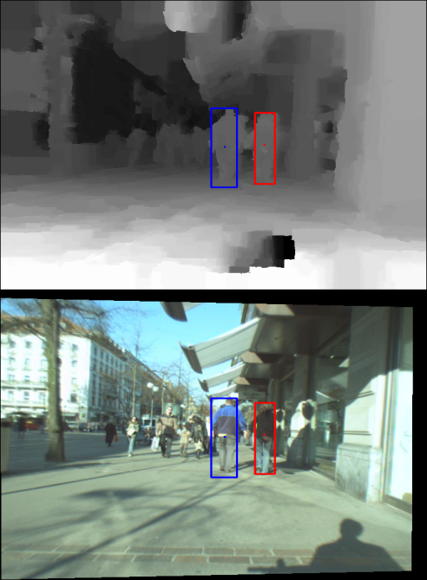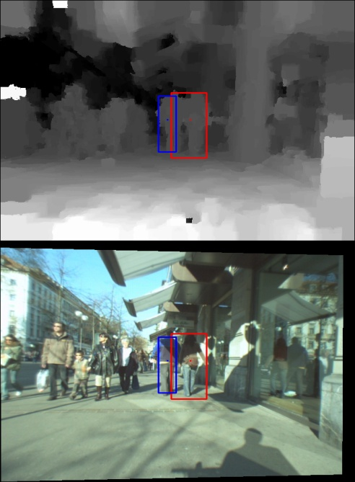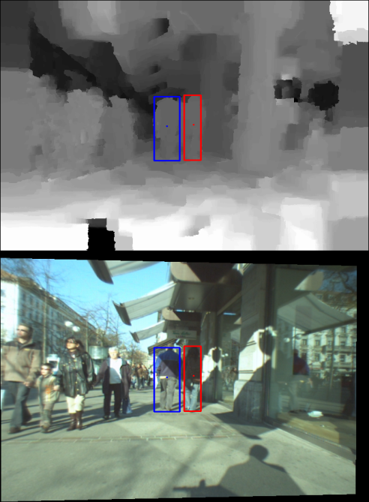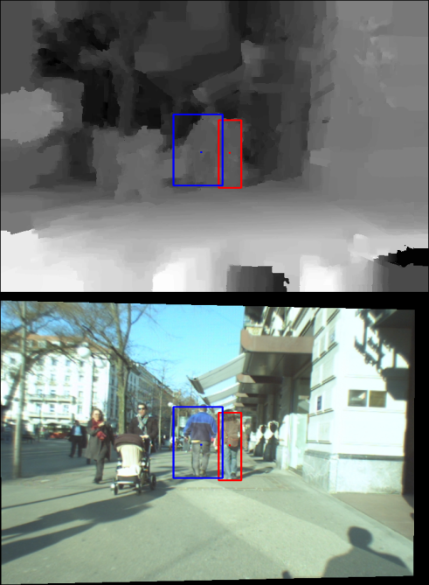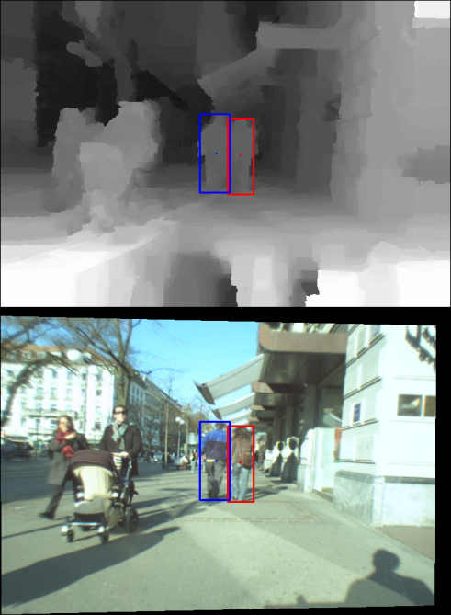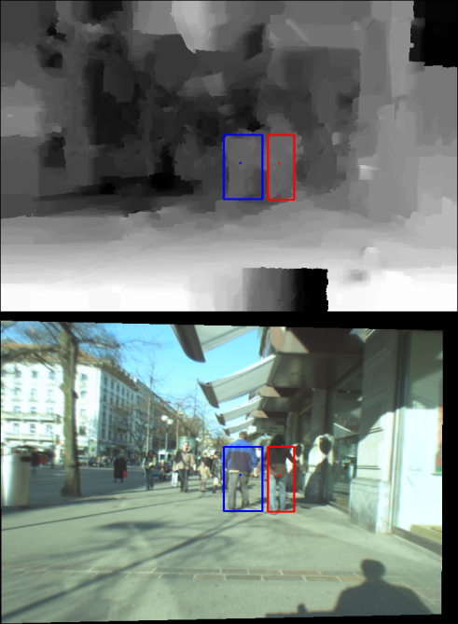

Figure 7. Tracking results of Sunny Day sequence where depth estimation frequently breaks down. At frames 36, 89, 122 and 215, depth map suffers from severe noises and uncertainty in depth estimation in both object and non-object regions which results in inaccurate segmentation. However, the tracker is still able to locate parts of objects with small amount of outliers. Thus the tracker always accurately tracks depth blob with object dominant depth group and recovers the object appearance model when it achieves valid depth estimation, for example, in frames 45, 95, 130 and 230.

**215# 230# 274#**

**95# 122# 130#**

**36# 45# 89#**

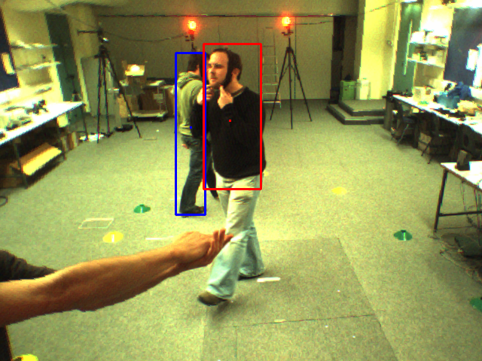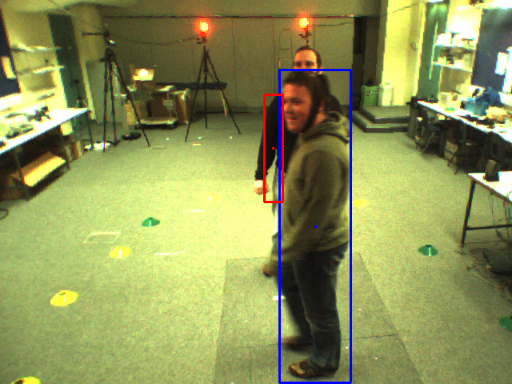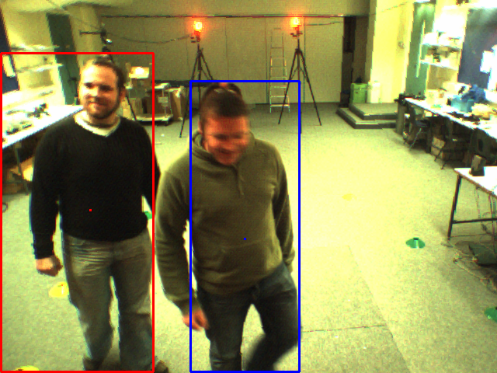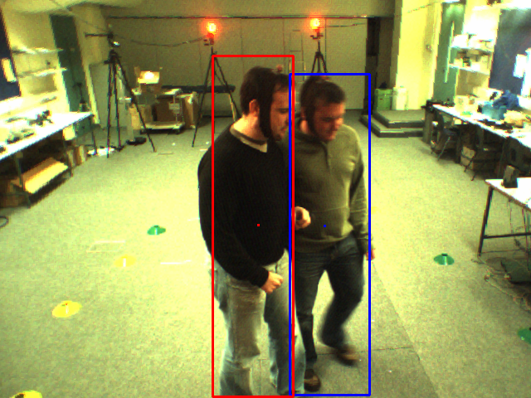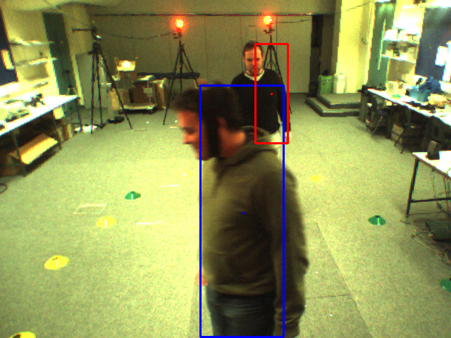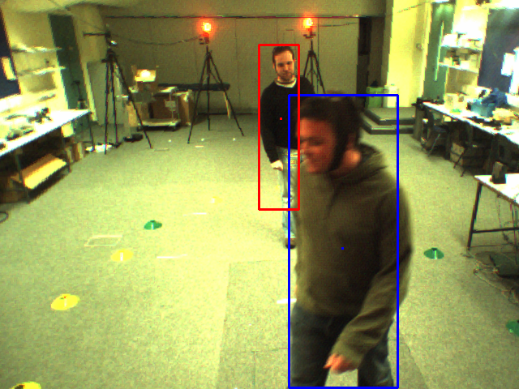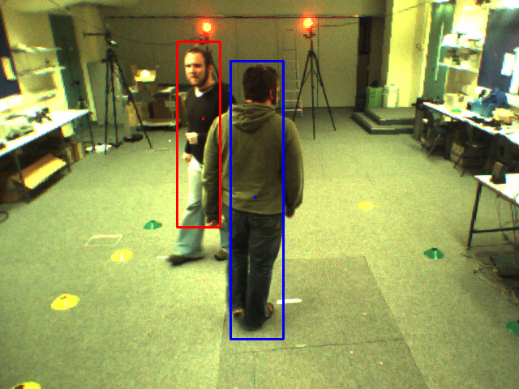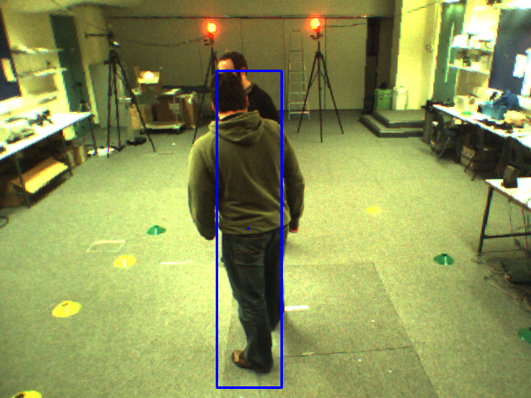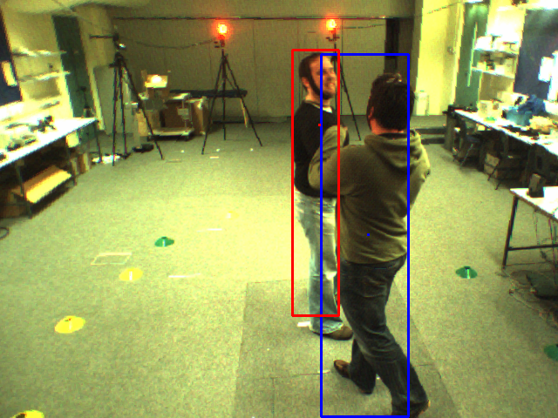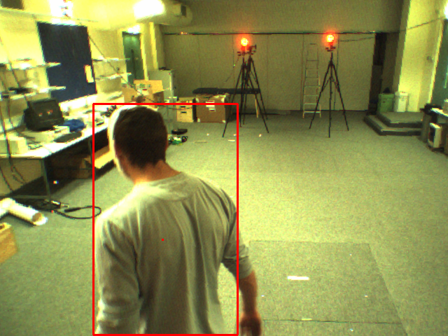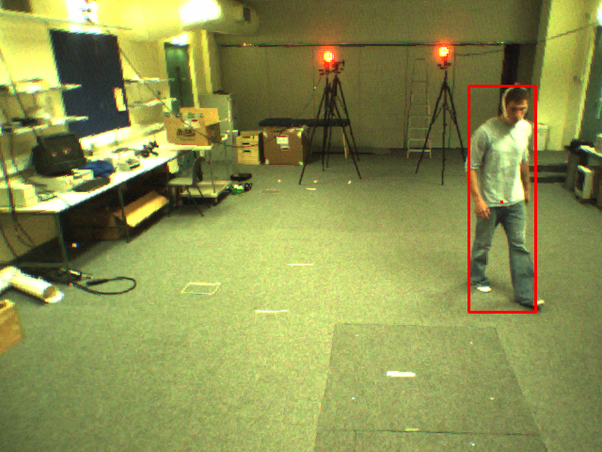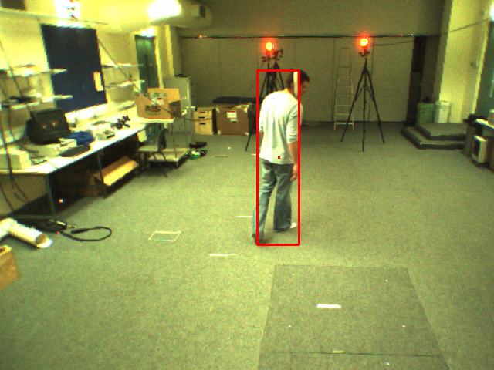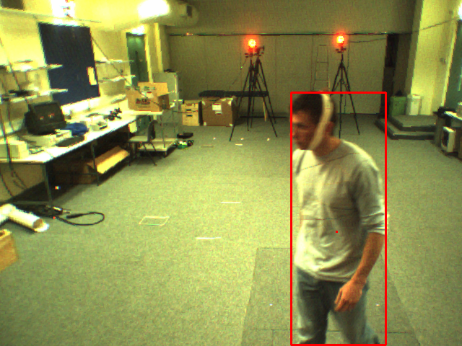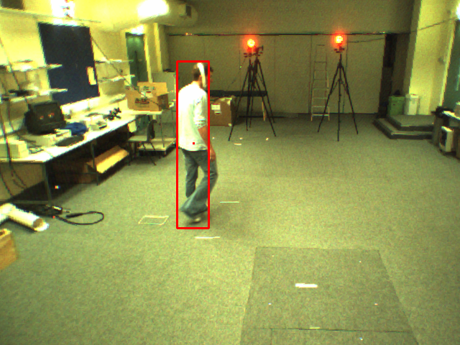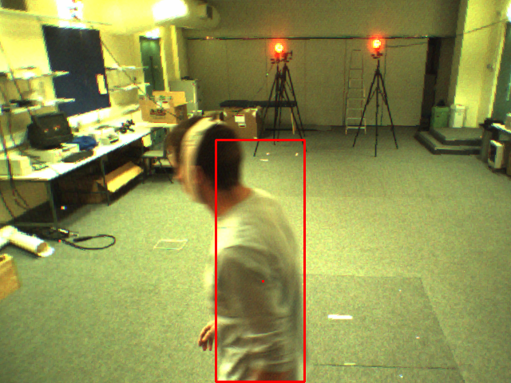

Figure 8. Tracking results of VICON1 and VICON2 sequences under indoor environment. The first and second rows show robust tracking in VICON1 under large scale and appearance changes. The following three rows display the ability of our tracking approach to handle interaction, partial and complete occlusion in VICON2.

**247# 266# 286#**

**062# 70# 73#**

**152# 173# 228#**

**63# 83# 116#**

**159# 161# 197#**

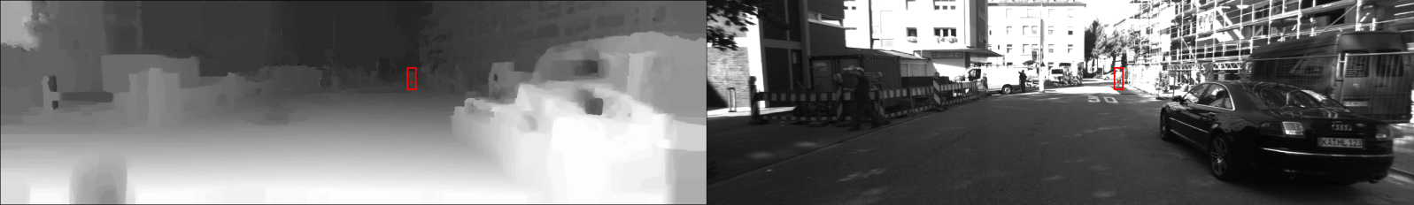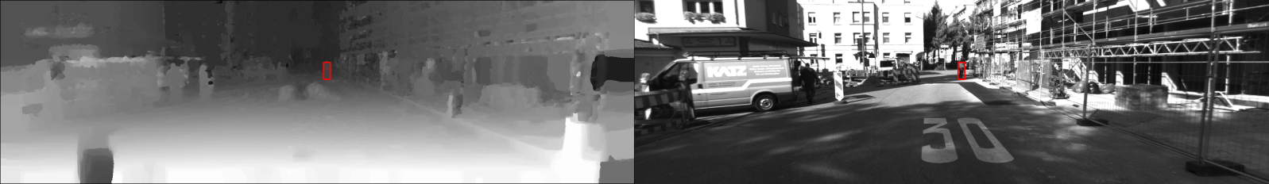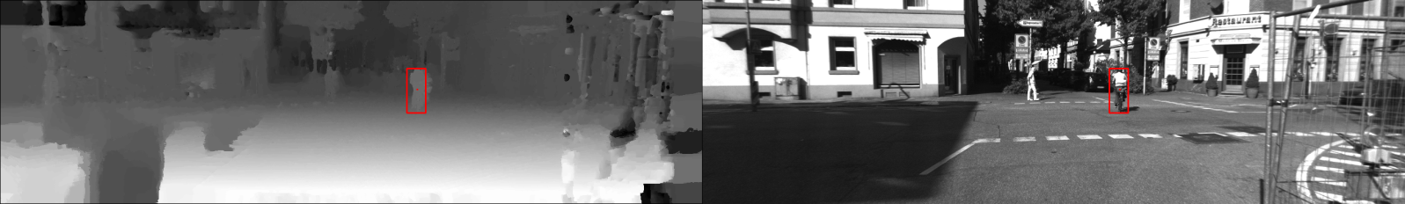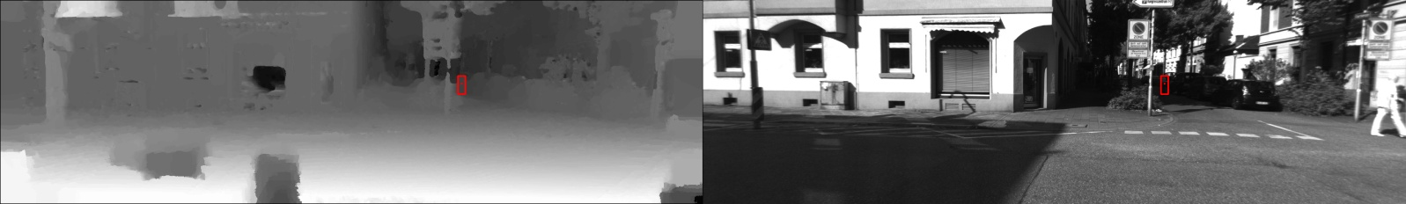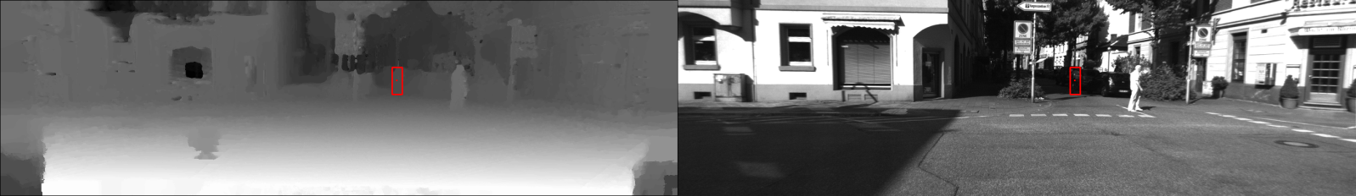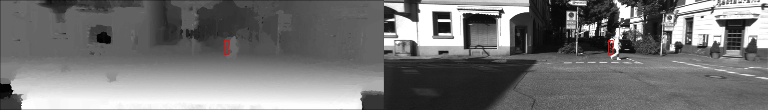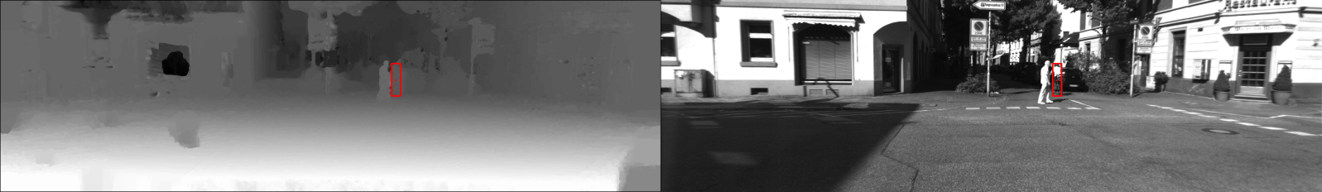

**1#**

Figure 9. Tracking results of a subsequence in Drive_0012. We can clearly see that the tracker can robustly track in gray-scale image sequence where appearance cue is impaired to provide sufficient information for object localization. At frames 1, 23 and 56, the object appearance undergoes sharp change due to rapid illumination alteration. After successful object reacquisition showed in frames 123, 125 and 127, the object enters a large shadow area at frames 135~159 where appearance cue mostly fails to act as an effective cue for object tracking. However, the depth cue still provides strong indication for object localization which ensures accurate tracking without drifting.

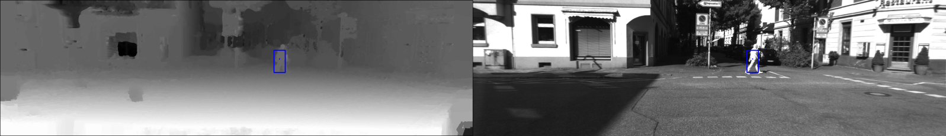

**159#**

**135#**

**127#**

**125#**

**123#**

**56#**

**23#**

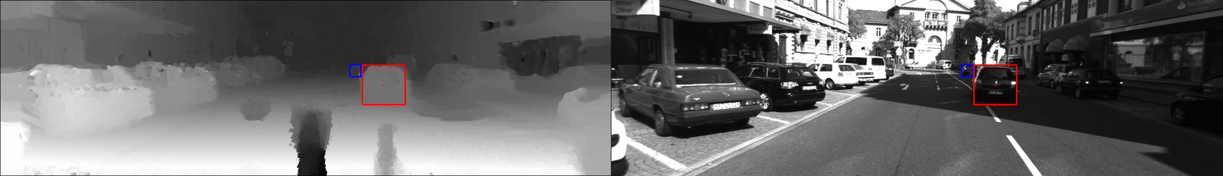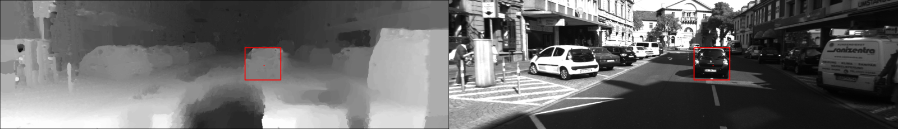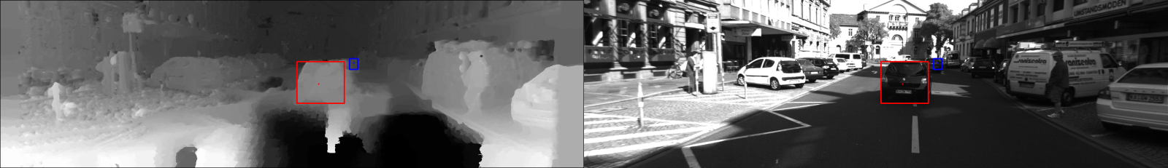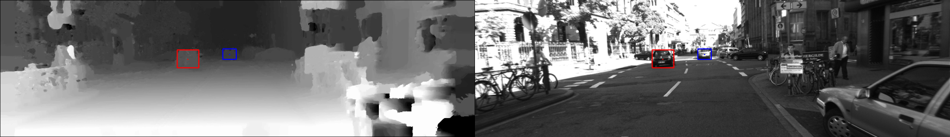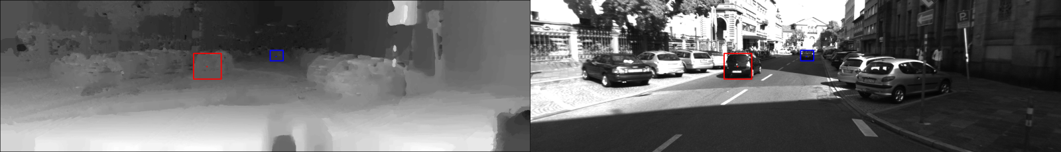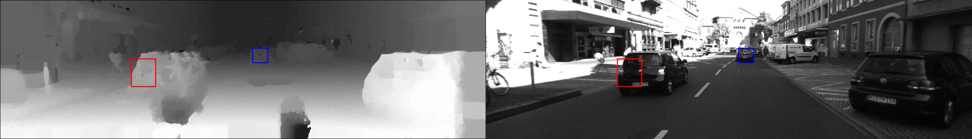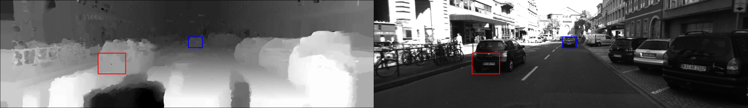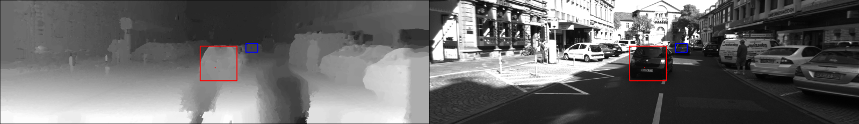

Figure 10. Tracking results of a gray-scale subsequence in Drive_0019. We test our tracking method on dynamic road environment by tracking cars. The tracker achieves good tracking results even under sharp appearance change in frames 16 and 43. Then it fails to segment the object (bounded by red box) well in frames 82 and 91 because the object does not hold consistent depth value within object area after depth clustering, which undermines object uniform depth assumption. However the tracker recovers from previous corrupted figure in 128# and successful handles occlusion between 134# and 154#.

**154#**

**141#**

**134#**

**128#**

**91#**

**82#**

**43#**

**16#**

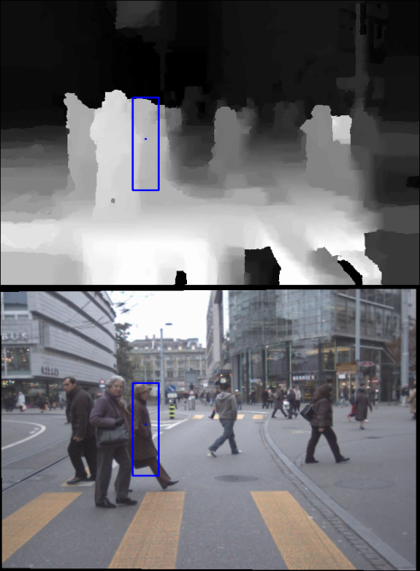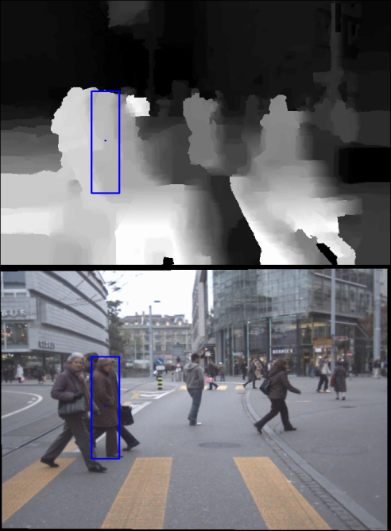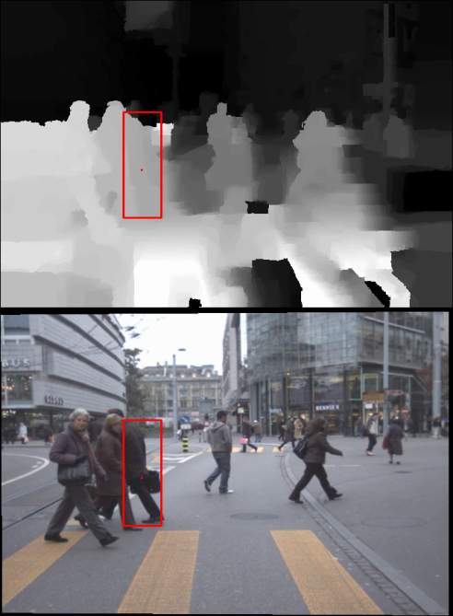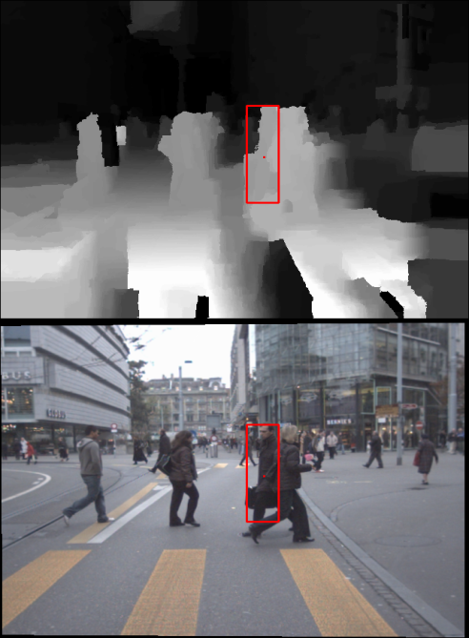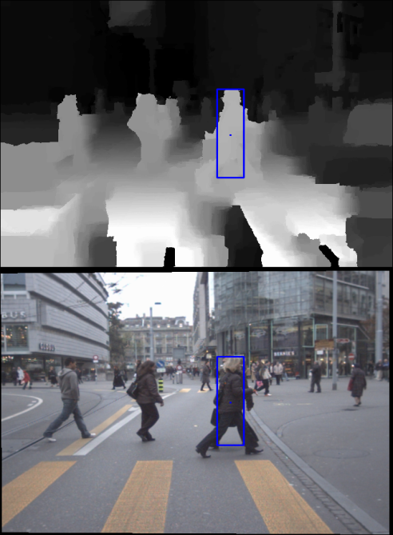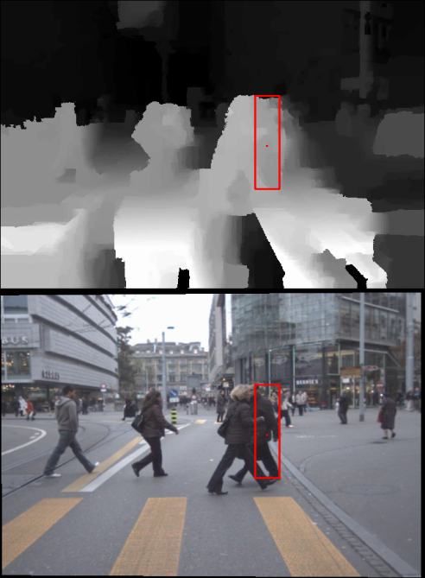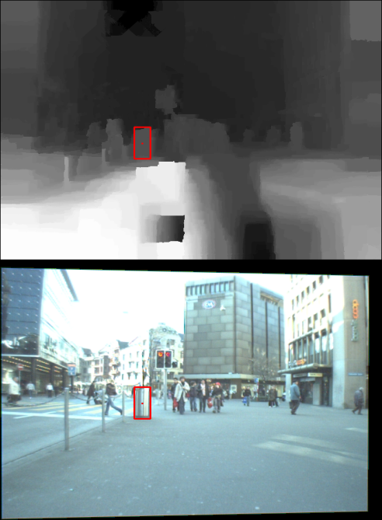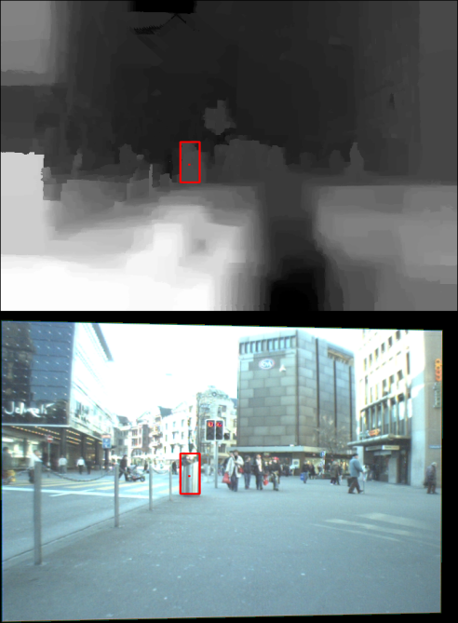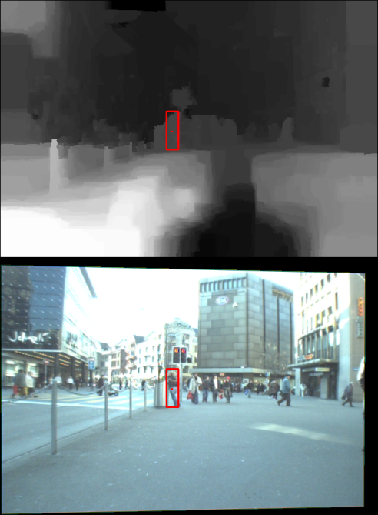

Figure 11. Failure cases on subsequences of Jelmoli (028#~058#) and Loewenplatz (160#~250#). The first row shows the case that the tracker fails to detect occlusion when sharp depth change occurs within object region while the **OB** retains similar depth as the object’s. The Second row shows a successful occlusion handling even when the **OB** retains extremely similar appearance to the object. The third row displays another failure case that more complicated occlusion patterns happen, which prevent the tracker from reacquiring the object near the **OB** while still tracking the **OB** in following frames. High level data association model is needed in such case and we leave it for future work.

**241# 242# 244#**

**218# 219# 220#**

**046# 051# 058#**